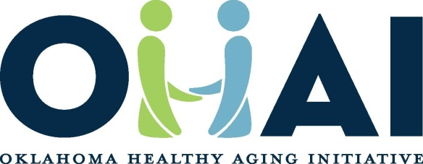

WWW.OHAI.ORG

For all group leaders:

I am Kari Kennedy-Gregory, RN Educator for the Central OHAI. The Oklahoma Healthy Aging Initiative (OHAI) is a statewide organization devoted to improving the health of older adults. We teach empowering health education classes for older adults and their caregivers, provide family and professional caregiver training, partner with health systems across the state to provide specialized geriatric care, and work with local leaders to promote the interest of older adults.

In 2016, we have two exciting new programs at OHAI:

* Family Caregiver Workshop
* Classes/In-Services for professional and non-professional caregivers

The Family Caregiver Workshop is a two-day workshop providing need-specific training for a person caring for someone at home. Our licensed medical team shares instructional programs focusing on caregiving responsibilities. The workshops aid in making activities of daily life easier to accomplish. Examples include bathing, dressing, fall prevention, dementia needs, varying legal matters, and addressing caregiver stress.  This workshop is $25 per person.

These workshops are for a caregiver going home with their loved one from a skilled nursing unit or someone living in independent living with a loved one and needing support in taking care of their loved one at home.

These workshops are held at the OUHSC campus but can travel to your location.

We also are excited to be able to provide classes and in-services. Please see the attached selection of available class. OHAI is excited to offer **2 FREE** Classes and In-services at your facility. These classes can be held for further education to the nursing staff, in family council meetings or caregiver support groups.

Please call for further information or if you are interested in booking a class or in-service.

Respectfully,

Karisa Kennedy-Gregory BSN, RN

RN Educator/Coordinator

Central Center of Healthy Aging

Oklahoma Healthy Aging Initiative (OHAI)

405-271-6424 Ext 51221

kari-kennedygregory@ouhsc.edu

Donald W. Reynolds Department of Geriatric Medicine

The University of Oklahoma Health Sciences Center

1122 N. E. 13th, ORB 1200, Oklahoma City, OK 73117

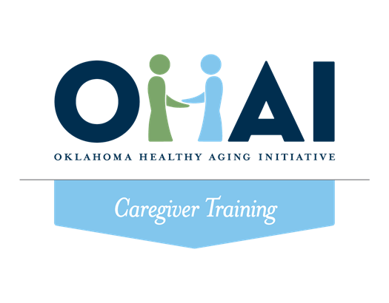

**OHAI Caregiver Classes and In-Services**

* Healthcare Team- Role of the Caregiver
* Ethical and Legal Issues
* Safety Precautions
* Documentation of Care
* Infection Control and Prevention
* Communication
* Lifting and Moving
* Basic Human Needs- Normal changes in aging
* Delirium, Dementia, and Alzheimer’s
* Nutrition and Fluid
* Body Mechanics
* Caregiver Stress
* Personal Care (1)
* Personal Care (2)
* Skin Care, Bowel and Bladder Care, Incontinence
* Pain Management
* End of Life Care

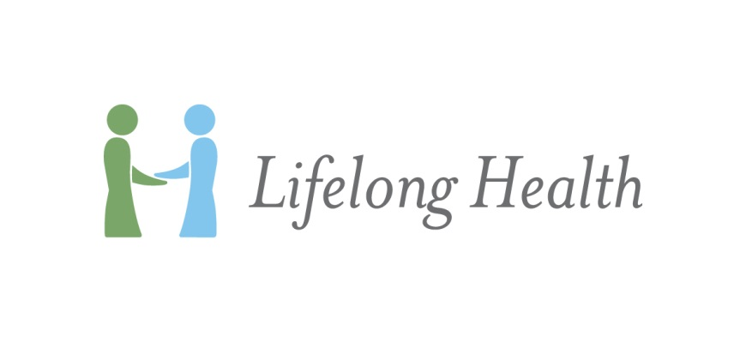

For information on class times and enrollment opportunities, call **405-271-6424** or contact us by email at **ohai@ouhsc.edu**.

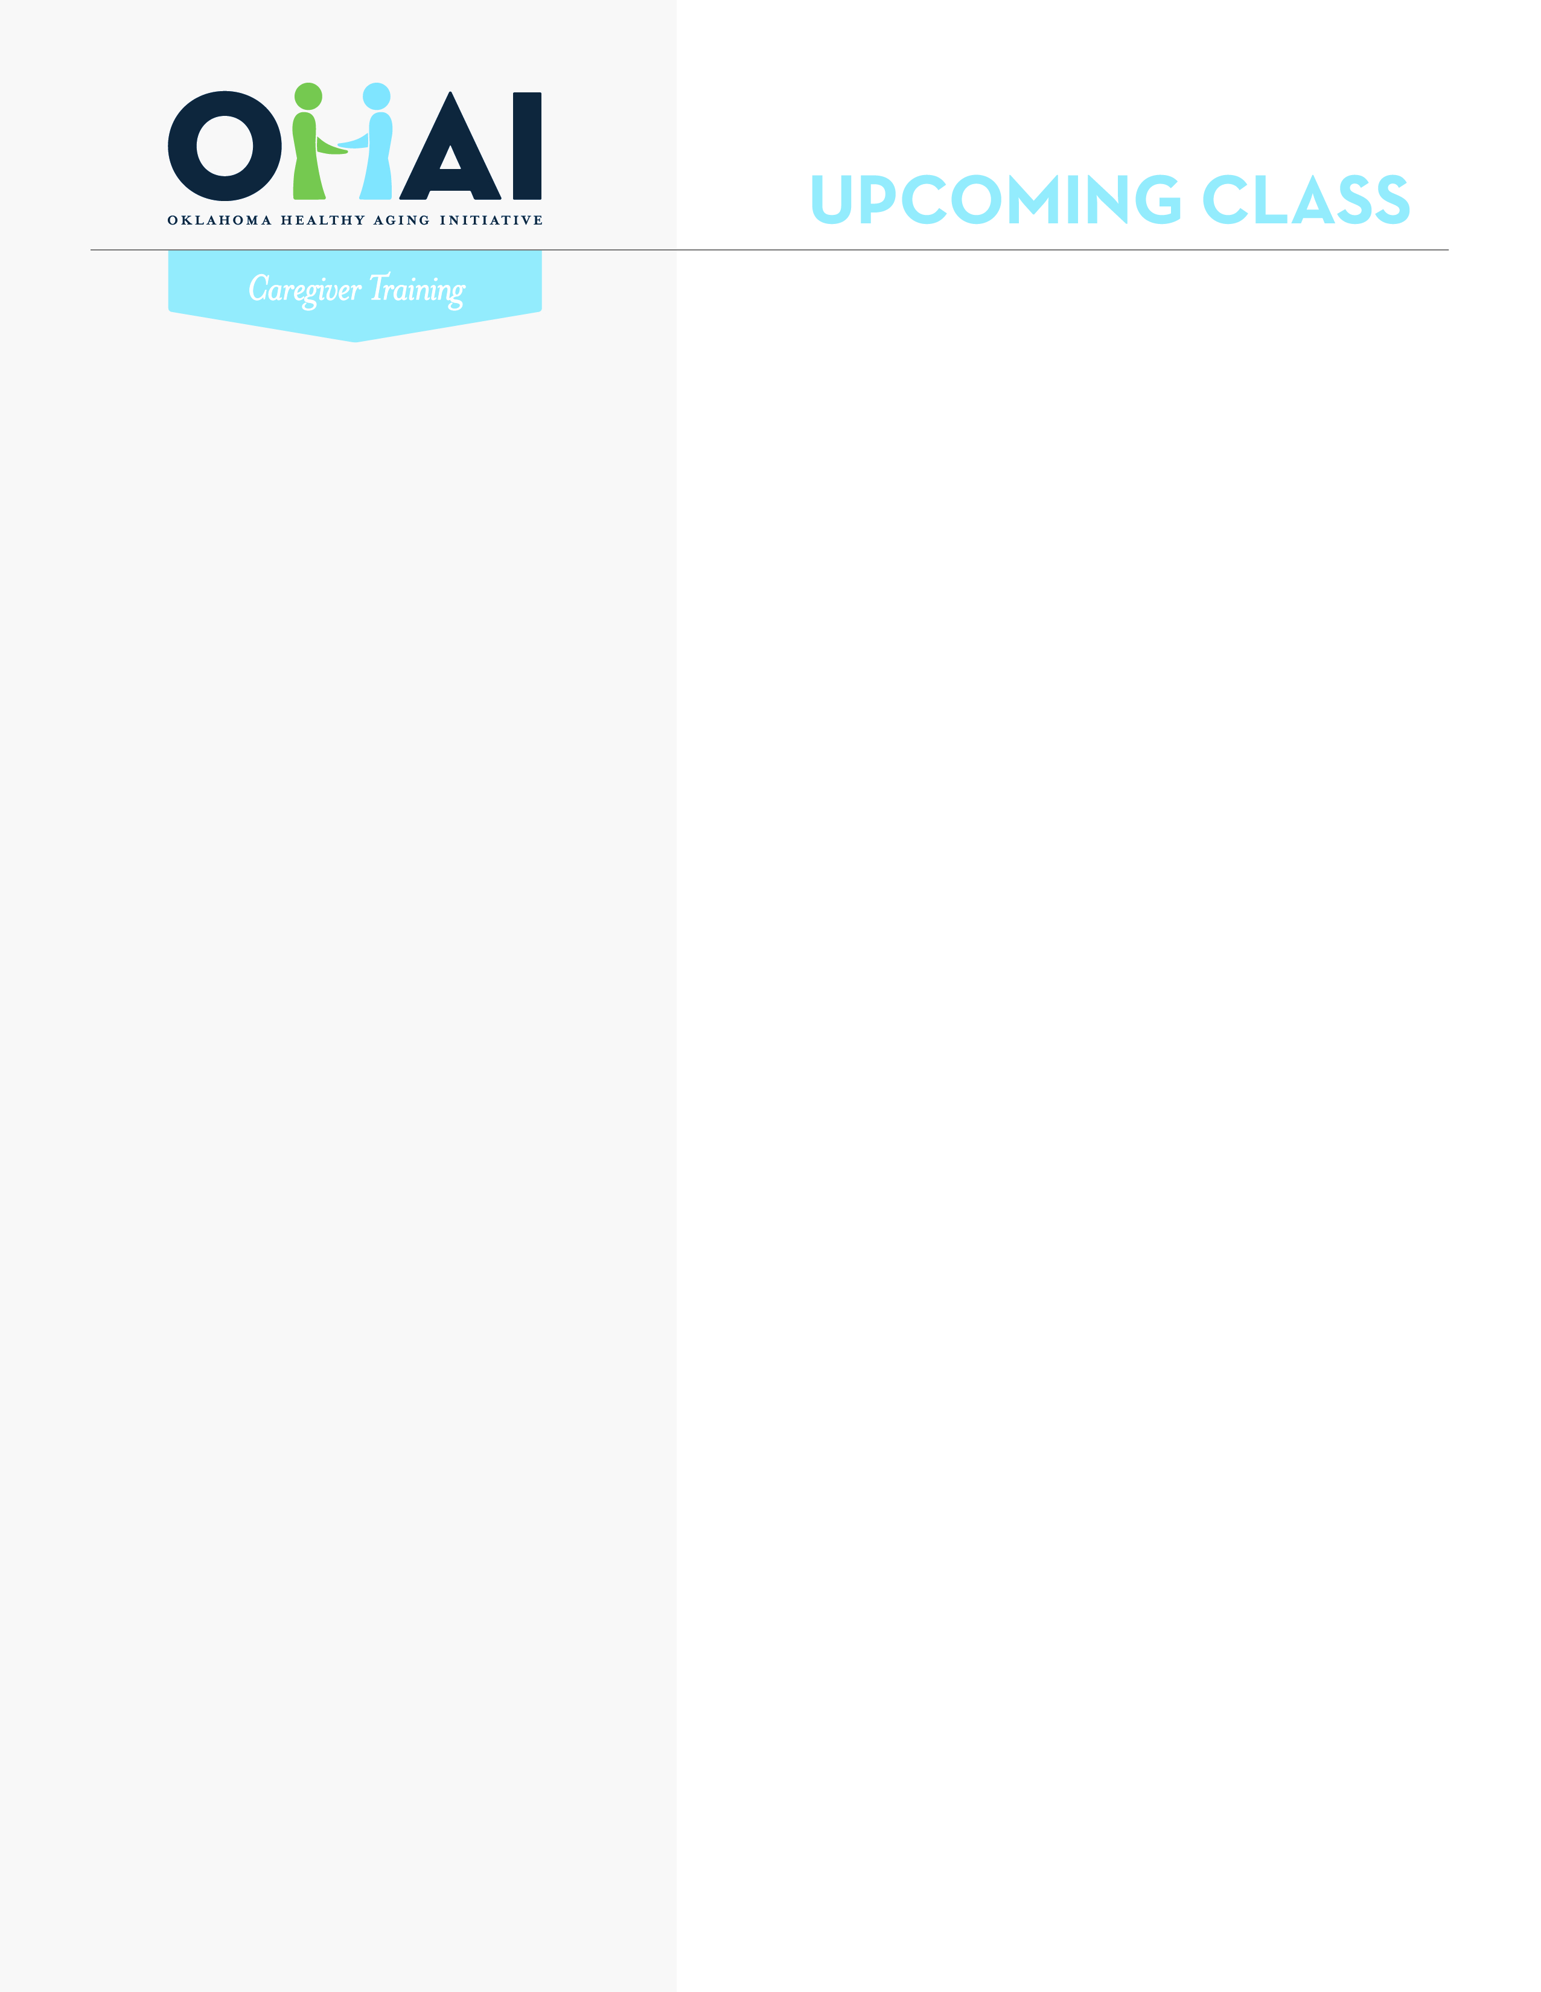

No matter how long you have been providing care for someone, this workshop will help you in your caregiving role. We will introduce you to techniques for assisting older adults with essential activities of daily living, along with methods to reduce frustration and stress.



**WHO THIS IS FOR**

Developed within the University Of Oklahoma Department Of Geriatric Medicine, our two day workshop is designed to provide basic needs training for anyone caring for an older adult at home or in a senior care facility. Our licensed medical team delivers the information which makes activities of daily living easier for caregivers, as well as the care recipient.  Through engaging class discussion and participation with hands-on activities, those who complete the workshop will gain the knowledge and skills to become a successful caregiver.

**WALK AWAY WITH TOOLS FOR:**

* Managing stress
* Nutrition
* Assisting with body movement & mobility
* Infection control
* Bathing and dressing assistance
* Successful communication
* Home & medication safety and much more

**CLASS DATES**   
**May 19, 20 9:00am to 3:00pm**

**June 16, 17 9:00am to 3:00pm**

**July 28, 29 9:00am to 3:00pm**

**August 25, 26 9:00am to 3:00pm**

**HOW TO REGISTER**

Call Maricela Buenfil (405) 271-6424

at the Central OHAI Center of Healthy Aging

or email CentralOHAI@ouhsc.edu.

**You must be registered in order to attend.**

**LOCATION**

Central OHAI Center of Healthy Aging

1122 NE 13th St., Suite 186

Oklahoma City, OK 73117

**Central OHAI   
Center of Healthy Aging**

OU Health Science Center

1122 NE 13th St., Suite 186

Oklahoma City, OK 73117

405-271-6424

CentralOHAI@ouhsc.edu

**OHAI.org**

*The Oklahoma Healthy Aging Initiative (OHAI) is a program of the Donald W. Reynolds Department of Geriatric Medicine at The University of Oklahoma and   
is supported by the Donald W. Reynolds Foundation.*

**FAMILY CAREGIVER WORKSHOP**